The **n-queens** puzzle is the problem of placing n queens on an n x n chessboard such that no two queens attack each other.

Given an integer n, return *all distinct solutions to the* ***n-queens puzzle***. You may return the answer in **any order**.

Each solution contains a distinct board configuration of the n-queens' placement, where 'Q' and '.' both indicate a queen and an empty space, respectively.

**Example 1:**

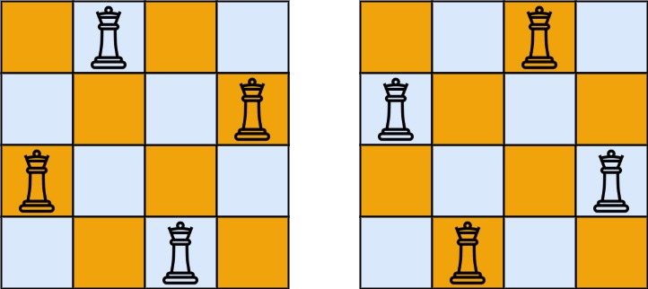

Input: n = 4  
Output: [[".Q..","...Q","Q...","..Q."],["..Q.","Q...","...Q",".Q.."]]  
Explanation: There exist two distinct solutions to the 4-queens puzzle as shown above

**Example 2:**

Input: n = 1  
Output: [["Q"]]

**Constraints:**

* 1 <= n <= 9